GSAR-NCP-R&G-2.2:2024

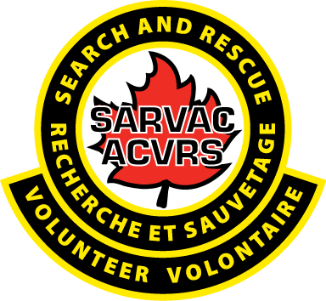

Ground Search and Rescue-National Certification Program Requirements and guidelines governing certification

Part 2: Certification Process – Searcher, Team Leader, and SAR Manager

Published in August, 2024
by the Search and Rescue Volunteer Association of Canada
24 McNamara Drive, Paradise, NL A1L 0A6

Certification Process – Searcher, Team Leader, and SAR Manager

Legal Notice
Appropriate to the SARVAC national certification body.
Disclaimer and exclusion of liability:
Intellectual property rights and ownership: As between SARVAC and the users of this document (whether it be in printed or electronic form), SARVAC is the owner, or the authorized licensee, of all works contained herein that are protected by copyright, and all trade-marks (except as otherwise noted to the contrary).
Authorized use of the document: This document is being provided by SARVAC for informational and non-commercial use only.

Table of Contents
Legal Notice 2
Table of Contents 3
Preface 6
Part 2: Certification – Searcher, team leader and SAR manager 7
0.1 Procedural documentation 7
0.2 Proposals for change to this part of the GSAR – NCP Requirements and guidelines 7
1 Scope 7
1.1 Purpose 7
1.2 Application 7
1.3 Terminology 7
2 Definitions and abbreviations 8
2.1 Definitions 8
2.2 Abbreviations 9
3 References 10
4 Certification for Searcher 11
4.1 Scope 11
4.1.1 Purpose 11
4.1.2 Intent 11
4.2 Certification requirements 11
4.3 Legacy – Searcher 11
5 Certification for Team Leader 11
5.1 Scope 12
5.1.1 Purpose 12
5.1.2 Intent 12
5.2 Certification requirements 12
6 Certification for SAR Manager 12
6.1 Scope 12
6.1.1 Purpose 12
6.1.2 Intent 12
6.2 Certification requirements 13
7 Field Experience – criteria 13
8 Certification Process: searcher, team leader and SAR manager 13
8.1 Certification policies 13
8.2 Certification process 13
8.3 Process support 13
9 Application 14
9.1 Purpose 14
9.2 Application 14
9.3 Application criteria 14
9.3.1 Age of majority 14
9.3.2 Membership 14
9.3.3 Requirements completion 14
10 Certification 14
10.1 Purpose 14
10.2 Searcher, team leader and SAR manager Certification 15
10.3 Code of Ethics 15
10.4 Responsibilities – GSAR-NCP Administration Office 15
10.5 Distribution 15
10.6 Revocation of certification 15
10.7 Details of revocation of certification 15
11 Assessors and Examiners/Instructors: Searcher, team leader and SAR manager 16
11.1 Purpose 16
11.2 Assessor - responsibilities 16
11.3 Assessor - need to recuse 16
11.4 Assessor - qualifications 16
11.5 Assessor – eligibility 16
12 National core competencies: searcher, team leader and SAR manager 17
12.1 Competency requirements 17
12.2 Demonstration of competency 17
13 National certification examination: Searcher, team leader and SAR manager 17
13.1 Purpose 17
13.2 Intent 17
13.3 Oversight 17
13.3.1 Availability 18
13.3.2 Requests 18
14 Reciprocity: Searcher, team leader and SAR manager 18
14.1 Purpose 18
14.2 Responsibilities 18
15 Dispute resolution: Searcher, team leader and SAR manager 18
15.1 Disputes 18
15.2 Notification 18
16 Data retention and registry: Searcher, team leader and SAR manager 18
16.1 Gathering data 19
16.2 Data retention 19
16.3 Registry of Service 19
16.4 Reporting requirements 19
17 Accommodations: searcher, team leader and SAR manager 19
18 Re-certification requirements: searcher, team leader and SAR manager 19
Annex A - National Core Competency: Searcher 21
Annex B - National Core Competency: Team Leader 22
Annex C - National Core Competency: SAR Manager 23
Annex D - GSAR-NCP Appeals Process – Complaints and Appeals 24

Preface
This is the first edition of the Ground Search and Rescue-National Certification Program (GSAR-NCP)-R&G-2.2:2024, GSAR-NCP Requirements and guidelines governing certification, Part 2: Certification process – Searcher, Team Leader, and SAR Manager. The GSAR-NCP Requirements and guidelines governing certification are hereinafter referred to as the GSAR-NCP R&G.

The content of the GSAR-NCP R&G fall within national/international industry standards for certification programs, thus supporting and evaluating competencies of Ground Search and Rescue (GSAR) volunteers for three (3) core roles in GSAR operations: Searcher, Team Leader, and SAR Manager.

Users should understand that the GSAR-NCP R&G do not have the force of law unless mandated by legislation or referenced in regulations of the Authority Having Jurisdiction (AHJ). Users are advised to contact the AHJ in their area to determine the extent that this document is referenced.

The GSAR-NCP R&G were developed through a highly collaborative effort between SARVAC, AHJ and the SAR Community as a whole. Numerous manuals and reference materials were consulted in the development of this document.

The facilitation and development process for the GSAR-NCP was provided by the Canadian Standards Association (CSA). The CSA Group gratefully acknowledges the financial and in-kind support from SARVAC, and financial support of the Government of Canada through the Search and Rescue New Initiatives Fund (SARNIF).

Interested parties may request copies of GSAR-NCP R&G through the GSAR-NCP Administration Office.

Notes:
- Use of the singular does not exclude the plural (and vice versa) when the sense allows.
- Although the intended primary application of the GSAR-NCP R&G is stated in the Scope, it is important to note that it remains the responsibility of the users of the GSAR-NCP R&G to judge its suitability for their particular purpose.
- The GSAR-NCP model was developed by consensus, which is defined by CSA Policy governing standardization – Code of good practice for standardization as “substantial agreement”. Consensus implies much more than a simple majority, but not necessarily “unanimity”.
- All inquiries regarding this publication should be addressed to the GSAR-NCP Administration Office, Search and Rescue Volunteer Association of Canada, www.sarvac.ca

GSAR-NCP-R&G-2.2:2024
Part 2: Certification – Searcher, Team Leader and SAR Manager

0 Introduction

  - Procedural documentation
The GSAR – NCP R&G governing certification (GSAR-NCP R&G-2.1, GSAR-NCP R7G-2.3 and this part) set forth the requirements and guidelines for the GSAR-NCP certification program.

0.2 Proposals for change to this part of the GSAR-NCP R&G
Proposals for change to this part of the GSAR-NCP R&G should be submitted in writing to the GSAR-NCP Administration Office.

1 Scope

1.1 Purpose
This part of the GSAR-NCP R&G sets forth the policies and procedures of the GSAR-NCP certification program regarding the certification of
- Searcher;
- Team Leader; and
- SAR Manager.

GSAR-NCP is a voluntary program. Currently, there are no statutory requirements for the certification of these roles or occupations set by AHJ’s in Canada.

1.2 Application
This part of the GSAR-NCP R&G also sets forth policies and procedures of the GSAR-NCP regarding operational responsibilities in certification activities.

1.3 Terminology
In this part of the GSAR-NCP R&G, “shall” is used to express a requirement, i.e., a provision that the user is obliged to satisfy in order to comply with the GSAR-NCP R&G; “should” is used to express a recommendation or that which is advised but not required;
“may” is used to express an option or that which is permissible within the limits of the GSAR-NCP R&G; and “can” is used to express possibility or capability. Where the term “authorize” has been used, a motion by the appropriate committee, or permission by designated GSAR-
NCP Administration staff, is required. Where the term “approve” has been used, a recorded vote is required.

2 Definitions and abbreviations

2.1 Definitions

Accommodation – an adjustment to training, testing, scheduling, verifying and like activities that makes it possible for candidates or applicants needing assistance to meet certification requirements.

Acquaintance Type Relationship – a person one knows slightly but is not a close friend, or is a person that you have met, but do not know well.

Appeal – request by an applicant, candidate, or certified person for reconsideration of any decision made by the certification body related to their expected certification status.

Assessor – an individual that can be the team coordinator, training officer, or knowledgeable GSAR group member, who verifies that the core competencies have been met and may provide guidance to the individual of the certification process.

The Board – The governing body of SARVAC, representing all GSAR organizations in Canada. Herein, referred to as the Board.

Candidate – an individual who is seeking certification within the national certification process.

Certificate – document issued by a certification body under the provisions of approved guidelines, indicating that the named person has fulfilled the certification requirements.

Certification process – activities by which a certification body determines that a person fulfills certification requirements, including recertification and use of certificates.

Certification Requirements – a set of specific requirements to be fulfilled in order to establish or maintain certification.

Complaint – expression of an issue, other than appeal, by any individual or organization to the certification body, relating to the activities of that body or a certified person, where a response is requested.
Endorsement - the process of quality assurance through which status is granted to an external training course (or suite of related training courses) by an endorsement body.
Endorsement Requirements (criteria) – a set of specified requirements or criteria to be fulfilled in order to establish or maintain endorsement.

Equitable – the absence of avoidable or remediable differences among groups of people, whether those groups are defined socially, economically, demographically, or geographically.

Examination – part of an assessment which measures a candidate’s competence as defined in the certification process.

Examiner/Instructor – person who is competent to teach the core competencies and/or score an examination.

Fair - equal opportunity for success provided to each candidate in the certification process.

Field experience - necessary Observable Performance determined by Assessors within the P/T Association, or by AHJ with respect to CSA Z1620-15 Core competency standards for ground search and rescue operations: Searcher, team leader, and SAR manager.

GSAR Group – individuals forming an organized volunteer GSAR response: consisting of Searchers, Team Leaders, SAR managers and possibly technically SAR trained personnel.

Jurisdictional Competency Prerequisites - competency requirements as outlined by the P/T Associations and/or the AHJ.

Recertification – to renew the certification granted through a certification body.

Revocation - a process by which certification is withdrawn or made void.

SAR Manager - a person who manages and coordinates a search and/or rescue incident, leads and directs the SAR resources, is trained and experienced in search and rescue, and might or might not be the Incident Commander.

Searcher – the person, reporting to the Team Leader, responding to an incident as a member of a GSAR group.

Team Leader - the person, reporting to the SAR Manager, responsible for the conduct of a ground
search and rescue team.

Verification – the process of ensuring the core competencies have been met as required by the GSAR-NCP Requirements and guidelines.

2.2 Abbreviations

The following abbreviations apply in this document:

AHJ – Authority Having Jurisdiction
GSAR – Ground Search and Rescue
GSARCC – Ground Search and Rescue Council of Canada
GSAR-NCP – Ground Search and Rescue National Certification Program
P/T - Provincial/Territorial
R&G – Requirements and guidelines
SARVAC – Search and Rescue Volunteer Association of Canada

3 References
CSA Z1620-15 Core competency standards for ground search and rescue operations: Searcher, Team Leader, and SAR Manager

CSA Z1625-16 Training curriculum standards ground search and rescue operations: Searcher, Team Leader, and SAR Manager

ISO/IEC 17024 Conformity assessment — General requirements for bodies operating certification of persons

4 Certification for searcher
Administrative Note
Developed and updated in consideration of ISO/IEC 17024, Conformity assessment – General requirements for bodies operating certification of persons, Clause 8 – Certification schemes and Clause 8 – Certification process requirements.

4.1 Scope
The process for an individual to obtain the SARVAC GSAR-NCP Searcher certificate.

4.1.1 Purpose
To establish the policies and procedures supporting the certification process for searcher under the GSAR-NCP.

4.1.2 Intent
The general purpose of the GSAR-NCP is to measure the competency; the level of knowledge, skills, and abilities possessed by searchers seeking certification, and to attest that applicants meet nationally recognized standards.

4.2 Certification requirements

Certification requirements for Searcher include the following components:
- National core competency;
- National examination; and
- Approval of the P/T Association or AHJ.

4.3 Legacy – Searcher/Team Leader
Legacy national certification may be granted to any searcher/team leader upon written request to the GSAR-NCP Administration Office or by their P/T Association through the Legacy Application. To be granted legacy, a member must be in good standing with a GSAR group for at least 10 years, within the P/T Association, or AHJ for searcher, and with 5 years being a Team Leader for the Team Leader Legacy.

As part of the Legacy Application, an Assessor must attest to the individual’s continued service and training as a searcher/team leader, and that the competency requirements, continued training, and experience for searcher as outlined in CSA Z1620-24Core competency standards for ground search and rescue operations: Searcher, team leader, and SAR manager have been met. Legacy applications will only be considered until June 30, 2025.

5 Certification for Team Leader
Administrative Note
Developed and updated in consideration of ISO/IEC 17024, Conformity assessment – General requirements for bodies operating certification of persons, Clause 8 – Certification schemes and Clause 8 – Certification process requirements.

5.1 Scope
The process for an individual to obtain the SARVAC GSAR-NCP Team Leader certificate.

5.1.1 Purpose
To establish the policies and procedures supporting the certification process for team leader under the GSAR-NCP.

5.1.2 Intent
The general purpose of the GSAR-NCP is to measure the competency; the level of knowledge, skills, and abilities, possessed by team leader seeking certification and to attest applicants meet nationally recognized standards.

5.2 Certification requirements
- Searcher Certification;
- Approval of the Association or by AHJ;
- National core competency;
- Experiential; and
- National examination.

6 Certification for SAR Manager

Administrative Note
Developed and updated in consideration of ISO/IEC 17024, Conformity assessment – General requirements for bodies operating certification of persons, Clause 8 – Certification schemes and Clause 9 – Certification process requirements.

6.1 Scope
The process for an individual to obtain the SARVAC GSAR-NCP SAR Manager certificate.

6.1.1 Purpose
To establish the policies and procedures supporting the certification process for SAR manager under the GSAR-NCP.

6.1.2 Intent
The general purpose of the GSAR-NCP is to measure the competency; the level of knowledge, skills, and abilities possessed by SAR manager seeking certification and to attest applicants meet nationally recognized standards.
6.2 Certification requirements
Certification requirements for SAR manager include all the following components:

- ICS 200 (ICS 300 is recommended);
- Ten (10) years of GSAR experience;
- Approval of the Association or by AHJ;
- National Core Competencies for searcher;
- National core competencies for SAR manager; and
- National Examination.

7 Field experience – criteria
Field experience, as it is related to competencies outlined in the CSA Z1620-15 Core competency standards for ground search and rescue operations: searcher, team leader, and SAR manager will be assessed based on the following:

- Training practicum;
- Operational exercises;
- Mobilization; and
- Membership proof (legacy – searcher/team leader only).

8 Certification Process: searcher, team leader and SAR manager

8.1 Certification policies
SARVAC, in conjunction with the CSA developed policies and procedures supporting searcher, team leader and SAR manager certification. No individual, entity, or interest group is permitted to establish certification policies and procedures or interpret policies and procedures established by SARVAC.

8.2 Certification process
The certification process for searcher, team leader and SAR manager is inclusive of the following activities:
- Application – includes criteria, legacy (searcher/team leader only), accommodations (if required), and reciprocity;
- Certification requirements – includes core competencies and examination certificate; and
- Certification – notification, revocation.

8.3 Process support
Certification supports include:
- Assessors and Examiners (if necessary);
- Document / data retention;
- Privacy / security; and
- Dispute resolution.

9 Application

9.1 Purpose
The purpose of this section is to establish policies and procedures associated with applications for searcher, team leader and SAR manager certification.
Procedures include:

- Applicant criteria;
- Legacy (searcher/team leader only);
- Accommodations; and
- Reciprocity.

9.2 Application
Applicants shall submit a completed GSAR-NCP Certification Application (candidate application and application package) to the GSAR-NCP Administration office at nacpadmin@sarvac.ca.

Note: The certification process will be supported by online systems to provide efficient and effective administration, data sharing, verification, appeals, records management, and supports both the mobility of certified practitioners and mobilization. Accommodations associated with application may be available where necessary and will be determined on an as needed basis.

9.3 Applicant criteria
Applicants for the GSAR-NCP searcher, team leader and SAR manager certification shall meet the following criteria:

9.3.1 Age of majority
The applicant must be at least 18 years of age prior to applying to the requested level of certification.

9.3.2 Membership
The applicant must be a current active member of a recognized GSAR group within the P/T Association, or by AHJ, as defined in these policies and procedures.

9.3.3 Requirements completion
The applicant must complete all certification requirements for the requested level of certification prior to receiving a certificate.

10 Certification

10.1 Purpose
The purpose of this section is to establish policies and procedures with certification and registration of a candidate’s application.

10.2 Searcher, team leader and SAR manager certification
Certification shall be granted to a candidate who successfully passes the certification process and who meets the required qualifications for searcher, team leader and SAR manager, including any applicable prerequisites.

10.3 Code of Ethics (Rules of Professional Conduct)
Applicants upon certification, will recognize and adhere to the rules of professional conduct outlined in GSAR-NCP Code of Ethics, available on the SARVAC website, addressing key principles for certified persons.

10.4 Responsibilities – GSAR- NCP administration office
Upon satisfactory completion of the certification process, the GSAR-NCP Administration Office is responsible for creating the certification documentation. The certification documentation must include a unique identifier, registered SARVAC seal, name of applicant, date of certification and expiry. A record of the candidate’s certification must be maintained in a database by the GSAR-NCP Administration Office.

10.5 Distribution
Successful candidates will be provided with certification documentation by mail within 20 working days upon receipt of final application.

10.6 Revocation of certification
Upon a review of the circumstances recommending revocation presented to the Board. The revocation of a certification can be implemented by the SARVAC board through a voting process.
The Board may appoint a subcommittee to assist the Board in the review of the revocation circumstances.
Where the Board revokes the GSAR-NCP certification of any individual under the provisions of these policies, the revocation will encompass all GSAR-NCP certifications issued to that person.
The individual will be notified by certified mail (to their address provided by the applicant).

10.7 Details of revocation of certification
Revocation can be implemented for, but not limited to, the following reasons:

- The individual is unable to obtain a clear Vulnerable Sector Check and/or Criminal Record Screening, if required;
- The individual has been ‘discharged for cause’ from their operations team(s). Causes may include, but not be limited to, disregard for the rights of others, gross misconduct, misuse of authority, and falsification of an official report;
- False information submitted on the application for certification; and/or
- Recommendations from P/T or AHJ on revocation on the basis of serious legal or professional misconduct.

11 Assessors for Searcher, team leader and SAR manager

Administrative Note Guidelines (current and updated) should consider ISO/IEC 17024, Conformity assessment – General requirements for bodies operating certification of persons, Clause 6 – Resource requirements addressing general personnel requirements, personnel involved in the certification activities, outsourcing, and other resources. Also, for the purposes of these guidelines, it must be noted that an assessor can be a training instructor or examiner (internal or external). If the assessor is external to the GSAR organization, the acceptance/recognition of their assessment must be sanctioned by the GSAR organization or the AHJ.

An assessor may not have the opportunity to witness first hand training, and therefore can rely on the verification of an instructor/examiner (Clause 12.2) for the successful completion by a student of a core competency being taught.
11.1 Purpose
The purpose of this requirement is to establish guidelines, policies and procedures for Assessors supporting searcher, team lead and SAR manager certification.

11.2 Assessor – responsibilities
Assessor responsibilities are:

- ensuring the objectivity and integrity of the GSAR-NCP certification process;
- following established GSAR-NCP R&G governing certification when conducting a certification assessment; and
- determines that an individual applicant has succeeded in meeting both the “knowledge and understanding” and “observable performances” portions of the CSA Z1620-24 Core competency standards for ground search and rescue operations: Searcher, team leader, and SAR manager.

11.3 Assessor – need to recuse
The Assessor shall identify any potential cases that present a conflict of interest surrounding the certification candidate being assessed to the GSAR-NCP Administration Office.

11.4 Assessor – qualifications
An Assessor shall qualify and maintain qualification through meeting the following criteria:

- identified as being a team coordinator, training coordinator/instructor, or possessing the knowledge, skills, and experience as a GSAR member and
- continuing to assess individuals on an annual basis.

11.5 Assessor – eligibility
Assessors are recommended by GSAR groups and approved by the GSAR Association and/or the AHJ. Once an assessor is approved, they will be added to a qualified Assessors list maintained by the SARVAC GSAR-NCP Administration Office.
Assessors are not eligible to assess under the following circumstances:

- the Assessor has more than an acquaintance type relationship with the certification candidate;
- the Assessor is aware of any situation that could pose an ethical dilemma;
- the Assessor is no longer a member of their Provincial Association; and/or
- recommendations from P/T or AHJ on revocation on the basis of serious legal or professional misconduct.

12 National core competencies: searcher, team leader and SAR manager

12.1 Competency requirements
GSAR-NCP shall certify applicants to the current edition of the CSA Z1620-24 Core competency standards for ground search and rescue operations: Searcher, team leader, and SAR manager.

12.2 Demonstration of competency
Applicants may demonstrate competency requirements for Searcher, team leader and SAR manager certification through various means. Assessors will determine the validity and acceptance of these means to effectively demonstrate the necessary competencies. These means include, but are not limited to:

- log books;
- training evaluations (applied learning, e.g., exercises, simulations, case studies);
- operational experience; and
- membership proof.

13 National certification examination: searcher, team leader and SAR manager

13.1 Purpose
The purpose of this section is to establish policies and procedures for the GSAR-NCP searcher, team leader and SAR manager certification examination process.

13.2. Intent
The intent of the examination process is to measure the level of knowledge, skills and abilities gained by a candidate seeking searcher, team leader and SAR manager certification, in an equitable, fair, and non-discriminatory manner.

13.3 Oversight
GSAR-NCP Administration Office will oversee the administration of all examinations. Examinations will primarily be administered in an online format. Certification examinations shall:

- be proctored, if necessary for Accommodations and
- require a pass score of 80%

13.3.1 Availability
Certification examinations shall only be available through the GSAR-NCP Administration Office for candidates applying for certification.

13.3.2 Requests
GSAR-NCP Administration Office will validate the location of the certification examination, if a proctor is required, prior to scheduling the examination.

14 Reciprocity: searcher, team leader and SAR manager
14.1 Purpose
The purpose of this section is to establish policies and procedures for awarding reciprocity to candidates certified by P/T Associations or AJHs, under the GSAR-NCP.
14.2 Responsibilities
The Board shall determine reciprocity on an individual case-by-case basis, supported by an appeal option to the GSAR-NCP Administration Office, which will include the following:

a) a certification candidate is responsible for submitting all required documentation, as outlined on the SARVAC website to the GSAR-NCP Administration Office for use in determining if reciprocity will be awarded; and
b) the candidate requesting reciprocity will be notified of the results of the application by the GSAR-NCP Administration Office.

Note: Falsifying information submitted as part of the reciprocity application process will result in denial of reciprocity and the candidate may be excluded from any further certification process.

15 Dispute resolution: searcher, team leader and SAR manager
15.1 Disputes
Dispute resolution is the responsibility of the Board. Disputes associated with GSAR-NCP policies and procedures associated with Searcher, team leader and SAR manager certification applications shall be administered by the GSAR-NCP Administration Office.
15.2 Notification
Notification of an appeal or dispute shall be submitted, in writing, to the GSAR-NCP Administration Office and will include any pertinent information regarding the appeal or dispute. Accommodations associated with appeal requests may be available where necessary.

16 Data retention and registry: searcher, team leader and SAR manager

Administrative Note Developed and update in consideration of ISO/IEC 17024, Conformity assessment – General requirements for bodies operating certification of persons, Clause 7 – Records and information requirements and Clause 10 – Management system requirements.

16.1 Gathering data
The GSAR-NCP Administration Office shall retain candidate applications and certification records in a secure system. A privacy policy for candidates applying for certification will be available on the SARVAC website.

16.2 Data retention
The GSAR-NCP Administration Office is responsible for maintaining all records associated with the certification process.
The GSAR-NCP Administration Office shall support policy that provides for maintaining an electronic and hardcopy summary record of each candidate, on an indefinite basis, that includes the following information:
- Name;
- Birth date;
- Candidate identifier number;
- Address;
- Candidate certification records, including applications, date of certification for level of certification awarded;
- Equivalency, reciprocity decisions, and accommodation documents (if applicable); and
- Appeal decisions (if applicable).

16.3 Registry of service
The GSAR-NCP Administration Office is responsible for maintaining the certification registry.

16.4 Reporting requirements
It is the policy of the GSAR-NCP Administration Office to provide reporting to the Board on at least an annual basis, and no more than a quarterly basis including:
- Numbers of candidates achieving searcher, team leader and SAR manager certification;
- Current Province/Territory of residence and SAR Group Association; and
- Aggregate data or evaluation data on certifications and the GSAR-NCP.

17 Accommodations: searcher, team leader and SAR manager
Accommodations will be reviewed on a case-by-case basis by the assessors of the applicant’s respective P/T Association, or by AHJ. The GSAR-NCP Administration Office will provide required documentation and guidance for accommodations.
18 Recertification Requirements: Searcher, team leader and SAR manager
Re-certification will be completed through a Recertification Application for searcher, team leader and SAR manager recertification, which will be required every three (3) years. The onus is on the certified candidate to complete the Recertification Application for searcher, team leader and SAR manager to maintain their certification.

Requirements to recertify for searcher:
- verification by an assessor, team coordinator/trainer of candidate’s participation in training, exercises, and operations using searcher core competencies;
- verification by P/T Association that candidate is a member in good standing;
- completion of Searcher GSAR-NCP online exam (code access obtained from SARVAC NCP Administration); and
- complete exam, submit exam certificate, along with a recertification application.
Requirements to recertify for team leader:
- verification by an assessor, team coordinator/trainer of candidate’s participation in training, exercises and operations using team leader core competencies;
- verification by P/T Association that candidate is a member in good standing; and
- completion of team leader GSAR-NCP online exam (code access obtained from SARVAC NCP Administration); and
- complete exam and submit certificate along with a recertification application.
Requirements to recertify for SAR manager:
- verification by an assessor, team coordinator/trainer of candidate’s participation in training, exercises and operations using search manager core competencies;
- verification by P/T Association that candidate is a member in good standing; and
- completion of search manager GSAR-NCP online exam (code access obtained from SARVAC NCP Administration); and
- complete exam and submit certificate along with a recertification application.

Annex A – National Core Competency: Searcher
The CSA Z1620-15 Core competency standards for ground search and rescue operations: Searcher, team leader, and SAR manager contains requirements and performance specifications for determining and evaluating competency for three core roles in ground search and rescue operations: Searcher, Team Leader, and SAR Manager.
Requirements and performance specifications for the Searcher role are identified in Clause 4. The Standard identifies the resulting competencies where the requirements and performance specifications are met. For the purposes of national professional certification, a Searcher candidate must demonstrate a set of core competencies from the CSA Z1620-24

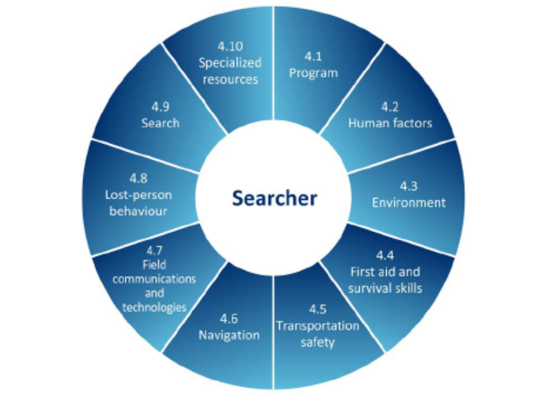

Annex B – National Core Competency: Team Leader
The CSA Z1620-15 Core competency standards for ground search and rescue operations: Searcher, team leader, and SAR manager contains requirements and performance specifications for determining and evaluating competency for three core roles in ground search and rescue operations: searcher, team leader, and SAR manager.
Requirements and performance specifications for the Team Leader role are identified in Clause 5. The Standard identifies the resulting competencies where the requirements and performance specifications are met. For the purposes of national professional certification, a Team Leader candidate must demonstrate a set of core competencies from the CSA Z1620-24.

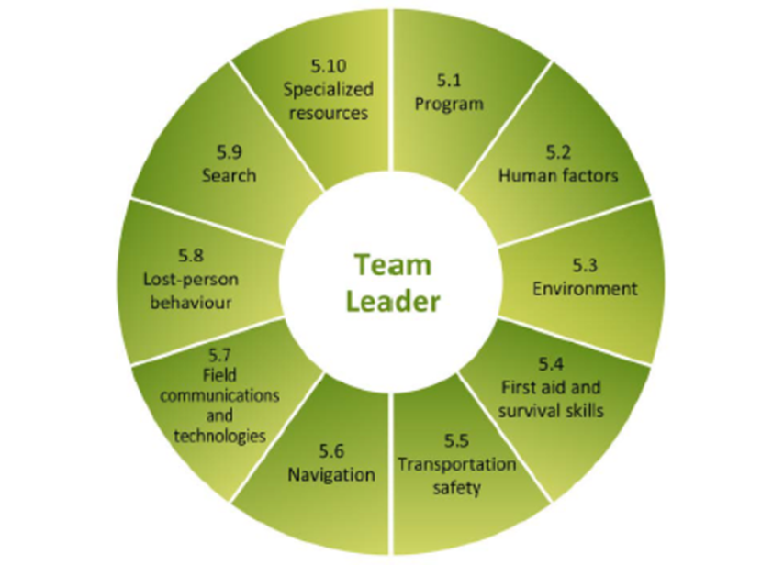

Annex C – National Core Competency: SAR Manager
The CSA Z1620-15 Core competency standards for ground search and rescue operations: Searcher, team leader, and SAR manager contains requirements and performance specifications for determining and evaluating competency for three core roles in ground search and rescue operations: searcher, team leader, and SAR manager.
Requirements and performance specifications for the SAR manager role are identified in Clause 6. The Standard identifies the resulting competencies where the requirements and performance specifications are met. For the purposes of national professional certification, a SAR manager candidate must demonstrate a set of core competencies from the CSA Z1620-24.
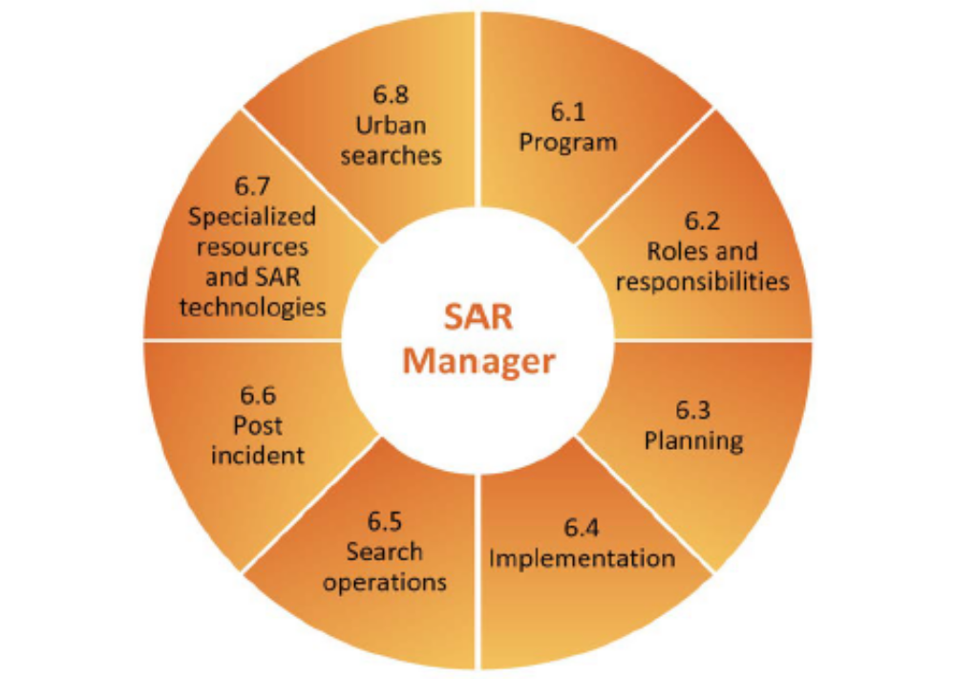

Annex D – GSAR-NCP Appeals Process - Complaints and Appeals
The GSAR-NCP is committed to fair, transparent and effective processes which include internal appeals. The internal appeals process provides an opportunity to re-examination decisions made by the SARVAC board.

Grounds for a complaint or appeal
There must be a legitimate reason or grounds for a complaint or request for an appeal; simply disagreeing with a decision is not sufficient. The purpose of a complaint or an appeal is not to repeat the original subject, application or procedure. Generally, for a complaint or an appeal to be considered, the following conditions would apply:

- the individual did not have a fair opportunity to present their case;
- the agency or individual making the original judgment was not/were not impartial;
- the process, policy or rule that was applied is flawed, unfair, or unreasonable. Here the process or rule itself is challenged rather than the specific application of the process;
- the correct facts were not considered and contributed to an error in the decision; or
- the correct rule or policy was not applied when making the decision.

Complaints or appeals will be considered from any party associated with the original subject or application. Individuals who were not a party to the original application and procedures cannot appeal the decision of the SARVAC board.

Submitting a Complaint or Requesting an Appeal
To file a complaint, a person must direct their issue and outline the grounds for the complaint to the GSAR-NCP Administration Office. The complaint must be writing and may be delivered by email, or by mail within 30 calendars days from the date the decision or action that is subject to the complaint was made.

To file a request for an appeal, a person must complete the Request for an Appeal Form, which asks the appellant to provide details on the grounds for the complaint or appeal as well as the solution or remedy they would propose.

The Request for an Appeal must be submitted to the GSAR-NCP Administration Office within 30 calendar days from the date the decision that is being appealed was made. It may be delivered by email, or by mail directly to the GSAR-NCP Administration Office​. There is no cost for requesting an appeal.

Complaints
Complaints shall be directed to the GSAR-NCP Administration Office for action in accordance with internal procedures and shall be provided impartial treatment.
SARVAC GSAR-NCP procedures shall:
- deal with complaints and appeals promptly;
- provide accessibility to the process to materially interested parties; and
- identify the SARVAC board role in the appeal process.

Procedural appeals – General
After having a complaint managed through the complaints process in Clause 1, any individual who believes that activities associated with endorsement or certification were subject to procedures that do not conform to the GSAR-NCP Requirements and Guidelines (2.2 Certification) may appeal to the SARVAC board for a review.

A procedural appeal shall be based on procedural matters and not on technical considerations.

Submitting a procedural appeal
Before an appeal regarding procedures is brought to the SARVAC board, the appellant should discuss the matter with GSAR-NCP Administration Office as this may lead to improved understanding and to a resolution that requires no further action.

All procedural appeals shall be submitted in writing, addressed to the Chair of the SARVAC board, and should:
- define the specific item that, in the opinion of the appellant, did not receive proper consideration by the GSAR-NCP Administration Office;
- quote the specific requirement or guideline (by clause number) that allegedly was not followed; and
- include documentation in support of the appeal.

Processing a procedural appeal
On receipt of an appeal, the Chair of the SARVAC board shall advise the board, and request copies of documents be submitted within 21 days, showing all action taken in relation to the subject of the appeal.

The Chair of the SARVAC board shall review available documentation and, through discussion with the GSAR-NCP Administration Office, appellant, and other parties as appropriate, recommend a course of action acceptable to the parties involved.

Appeals to the SARVAC board shall be handled by correspondence except that if it is deemed it necessary, a sub-committee may be called to review a particular appeal (see Clause 2.5).

Decisions made by the SARVAC board will be based on affirmative votes, by at least two-thirds of the total voting membership, whether to deny or uphold the appeal.

The appellant shall be notified of the decision of the appeal via the GSAR-NCP Administration Office.

Review
The decision of the SARVAC board shall be final.

If an appeal and the decision of the SARVAC board, more specifically, addresses the suspension or revocation of an individual’s certification and/or associated membership as a result of any disciplinary activities, the SARVAC board may, by special resolution, rescind or alter the action.
Meetings
When, in the opinion of the chair of SARVAC board it, is necessary to review a particular appeal, the Administration Office, acting as a Secretary for the SARVAC board, shall call a meeting within 21 days.

Note: Consideration should be given to inviting the appellant, and GSAR-NCP Administration Office staff.

